###### 

Surface Attack Tactics (SAT) Handbook

494th vFS / 108th vFS / 388th vFS

Handbook

132nd Virtual Wing

[www.132virtualwing.org](http://www.132virtualwing.org/)

This work is licensed under a [Creative Commons Attribution-ShareAlike 3.0 Unported License](http://creativecommons.org/licenses/by-sa/3.0/).

Surface Attack Tactics (SAT) Handbook

|  |  |
| --- | --- |
| Applies to: | 494th vFS / 108th vFS / 388th vFS |
| Type: | **Handbook** |
| Version: | 0.4 fourth draft |
| Published date: | [Publish Date] |
| Document responsible: | Neck |
| summary of changes: |  |
| References: | *476th: 476TTP3.3.A10 -24APR16 (*[*LINK*](http://www.476vfightergroup.com/downloads.php?do=file&id=376&act=down&actionhash=guest)*)*  *Eddie, 476th Forums: Air-to-Surface Weapon Delivery Methods (*[*LINK*](http://www.476vfightergroup.com/showthread.php?3131-Air-to-Surface-Weapon-Delivery-Methods)*)*  *Andy Bush: Combat Mission Planning Considerations (*[*LINK*](http://www.simhq.com/_air/air_009a.html)*)*  *“Falcas”: Weapon Delivery Planner Manual by (*[*LINK*](https://burgers6.home.xs4all.nl/files/WDP1.3%20OF%20Manual.pdf)*)* |

Contents

Introduction 4

Chapter 1: Planning your mission. 5

Step 1: Target Identification / Photo Study / Big-to-Small 5

Step 2: Type of delivery 7

*High or Low level ingress.* 7

Step 3: Weapon Selection / Probability of kill Criteria 8

Step 4: Dive angle and release height 9

Step 5: Attack heading and approach 9

Step 6: Leaving the target area 9

Step 7: Attack tactics 9

Step 8: Ingress considerations 11

Step 9 : Contingenices 13

Chapter 2: Useful information 15

Three Point Attack Brief 15

Fence Check 15

Attack methods 15

Roles: 15

Dive 16

Level 16

Toss/Loft 16

Mutual support Attack Geometry 17

High/medium altitude tactics 19

Low altitude tactics 21

Buddy lasing 22

Ground lasing 22

Holding patterns 22

Mission profiles 24

Chapter 3: Weapon Delivery Methods 27

Gun deliveries 27

Medium/high altitude tactics. 31

Low/very low altitude tactics 33

Pop-up deliveries 35

Safe Escape Maneuvers (SEM) 37

Chapter 4: Z-Diagrams 39

40

Z-Diagrams 494th 41

Z-Diagrams 388th 43

Z-Diagrams 108th 43

Surface Attack Tactics (SAT) is the…..

Close Air Support (CAS) is air action by fixed-wing and rotary-wing aircraft against hostile targets that are in close proximity to friendly forces, and requires detailed integration of each air mission with the fire and movement of those forces.

# Introduction

Scope: This document outlines the Tactics Techniques and Procedures (TTP's) for surface attacks with fast jets in the 132nd Virtual Wing. Each squadron will have their own Standard Operating Procedures (SOP's) for aircraft squadron specifics in regards to surface attacks.

Content: This document is divided into X chapters. Chapter 1 describes the planning process for a successful surface attack. Chapter 2 contains useful information. Chapter 3 contains

Pilot responsibility: Use common sense. TTP's describe technical and tactical procedures for most circumstances, but is no substitute for common sense and judgment. It is the pilot's responsibility to fly the aircraft safely and effectively in all circumstances, as required to accomplish the mission.

Deviations: Deviations from these TTP's are approved as long as they are communicated to all parties operating together.

Recommended changes: Improvements and recommended changes to this TTP should be stated to the Wing Command Staff.

You are a new flight lead, tasked to fly deep into enemy territory to bomb a building protected by SAM and AAAs How do you get to the target, how can you destroy it, and how do can you come back alive? This is the big questions for all strike missions.

How and what can you do?

One option is to avoid being seen. We can stay below the radar and pop up just before we drop our ordnance. This will give the enemy only a short time to track and thus a short time to aim and shoot at you. You could also stay above the threat and drop your bombs from a safe altitude. Maybe you could stay far away from the threats and toss the bomb to the target. But when do you go up? How high do you climb?

Planning is part of the answer. If you plan your attack, you will have better chances of surviving the mission. Mutual support and cooperation with your wingman and other flights is another part of the answer.

# Chapter 1: Planning your mission.

What do we need? This is always a good question to start with. When you know what you need, you also know what you should be looking for. For a start we need to know what the target is. Is it a “point”, like a radar dish, or is it a long target like a bridge or building?

If it is a “point” it doesn’t matter from which direction you attack it. If it’s a long bridge you might want to think about attacking it along its axes. This way you can ripple your bombs in a “stick”. What is the elevation of the target? Is it on a mountain or at sea level? What is the threat that surrounds the target? Can you find a route around AAA and SAMs? What does the surrounding look like? There could be a mountain blocking your route during the attack or during the exit. Do we ingress at a low or a high altitude? As you can see, there is a lot to think about. Here are 9 steps to follow that will aid you through the process.

### Step 1: Target Identification / Photo Study / Big-to-Small

The study of the target.

Prior to any mission you should gather all available information, maps, imagery and intelligence. Information can be found in various sources such as the mission brief, Air Tasking Order (ATO), target packs, DCS Mission Editor or Combat Flite.

The importance of this study goes far beyond knowing what the particular target looks like. This study is a three-step process.

##### First,

you want to look at the overall target area. Use DCS Mission Editor or Combat Flite maps and various target photos to “see” the position of the target from a “big picture perspective.” This is very important. You will approach your target at high speed and often at low altitude, where your radius of vision is limited. Your attention will be split between navigation concerns and analyzing, interpreting, and possibly responding to enemy threats. You will not have the luxury of circling the target at a comfortable altitude while you search for your target. You want to get in, destroy your target, and then get out before the enemy can get his act together.

Your “big picture” study has one purpose…you want to locate significant navigational references that you will use to “walk” your eyes to the target. As an explanation, let’s say the target is a truck convoy located near a bridge. As you run in to the immediate target area, you first locate the river. You follow the river until you get a tally on the bridge. You know from your target study that the truck convoy is situated in a particular direction from the bridge. Use your run in heading to the bridge as a twelve o’clock reference. Then translate the target’s location relative to the bridge into a clock position. For example, as you approach the bridge, you look to the bridge’s nine o’clock to find the target. Use this step-by-step process to get your eyes on the target in a methodical manner. Do not leave it to luck or chance to find your target. Your sim map and target photos make it possible to build your mental picture of this “big picture.” Using the “big picture to specific target” technique helps you find your target quickly, leaving you additional time to devote to achieving a successful one-pass attack.

##### Second.

Now, let’s consider what the target actually looks like. Use your maps and target photos to get a general picture of the target layout. . See how long the target is. Then you can decide on ripple and spacing. Notice the colour of the target. This might help during the day. A dark building can be found nicely when it has a light background. Try to find out what the elevation of the target is. What is the weather like? Can you see the target when you are at 3.000 feet? This will give you the first idea for the ingress altitude.

Using the convoy again as an example, determine if the convoy is strung out in a line or grouped together like a herd of cattle. Note the general compass orientation of the target. Determine if your attack heading will take you down the length of the convoy or across it. This heading is called your “attack axis.” Your weapon effectiveness is affected by your choice of attack axis. For example, when using CBU bomblets, you want to spread the bomblets along the length of the convoy rather than across it. Your target study may give you the location of that threat in the convoy. Study the target photos to find the unique physical characteristics of the target. Look for easily identifiable features. You want to be able to recognize your target quickly. You do not want to confuse it with a less-valuable target. The value of knowing what your target looks like ahead of time cannot be overemphasized. You can never be too familiar with the target.

Take a look at your target. When it’s an elongated target, note the heading to which it is aligned. Write it down and use it in your planning. See how long the target is. Then you can decide on ripple and spacing. Notice the colour of the target. This might help during the day. A dark building can be found nicely when it has a light background. Try to find out what the elevation of the target is. What is the weather like? Can you see the target when you are at 3.000 feet? This will give you the first idea for the ingress altitude. Also take a look at what is around the target. This is for a mental picture so you can recognize the target quickly. For example look at roads, mountains and buildings. Maybe make a small sketch of the surrounding and the big objects.

##### Third.

Anticipated threat level. You also need to study the anticipated air and ground threats ahead of time. You can determine their location and numbers. This will help you plan your route of flight. The type and capability of the enemy threat level will determine your ingress altitude and formation. Here are some items to remember:

#### Air threats:

Study both the number and type of air threat. Determine what type of air-to-air weapons you may have to defend against: IR, radar guided, or both. Determine from which direction or airfield the air threat is likely to come from. Note if the enemy will have an AWACS capability.

#### Ground threats:

Real world pilots will take special precautions to study enemy SAM and AAA threat positions and capability. They will draw “threat rings” on their maps to show maximum engagement ranges for those threats. You can do the same type of planning. Use your sim manual to note missile and gun maximum ranges and altitudes. Plot these on your sim map and then compute waypoints to fly a route to avoid these areas. Make best use of terrain masking as part of this planning.

Look at the positions of AAA, SAM’s and radar stations. You should in this step get a plan working in your head. If you can not think of any route to the target, stay home or request SEAD strikes prior to your attack. Check if objects like mountains or cities block your entry and exit. You should look in a radius of about 10nm to 12nm. You can change the distance for the starting point a little bit. Calculations starts from a point that is the same elevation as the target. If you start higher than the target, you will end up at the wrong place when you turn in to the target.

### Step 2: Type of delivery

You can use four different types of tactics for an attack.

* A Pop-up attack
* High Altitude Dive Bombing
* TOSS delivery attack
* Level delivery (Precision Guided Munitions)

Every advantage has its disadvantage. This applies to every type of attack. Using a Pop-Up you can stay below the radar of most of the SAMs. Although you should fly fast, but beware: you are in range of MANPADs and AAA. A HADB will put you above most of the MANPADs and small SAMs but you will be a nice target for high altitude SAMs. The TOSS delivery will keep you low and at a distance of the target. But the accuracy of hitting the target is smaller. A level delivery from high altitude can be good for delivery of precision guided munitions with stand-off range to the target. Which one do you select for the correct situation? This question together with step 1 will be the biggest decision you have to take.

#### High or Low level ingress.

First make a decision between a high or a low level ingress. The choice of a high or low ingress is actually only about the last part of the ingress. Picture a circle of about 30nm. Everything that is outside of 30nm range of the target is en route and can be flown at a fuel economic altitude. Plan your routing around SAMs and other threats when you are ingress to the target. Getting into the 30nm range of the target you might get into the range of SAMs or fighters that cannot be avoided. At this stage there are two options:

#### Low level ingress

The first option is usually a good choice in the beginning of campaigns or when the threat level is high: Low level ingress. The target area is protected by medium or high altitude SAMs and the chance of enemy fighters is still high. This way you can avoid detection of the enemy radar and try to stay away from enemy fighters. Always try to stay Air-to-Air until the last possible moment.

With loe level ingress we again have two options. Here we can use a pop-up or a TOSS delivery. Choosing the Pop-up or TOSS depens on the target to hit and if you can fly over the target.

**Pop-up:** This type of delivery can be useful for all static targets such as buildings, brigdes, runways and even veichles. The ordnance that can be used is the whole range from low and high drag dumb bomb, cluster and laser guided bombs.

**TOSS:** For a low level ingress we should use a LAT deliver. LAT stands for Low Altitude TOSS. During this delivery the bomb will release upwards. The range will become greatr but the accuracy will be smaller. Therefore the best type of bomb used will be a cluster bomb. This can be a suitable way of attacking a group or veichles, or SAM sites. However, also freefall bombs can be used against large targets.

#### High level ingress

The second option you will most likely encounter later in the campaigns or conflicts when the threat level is lower. Most of the SAM radars have been disabled and only MANPADs and AAA are a threat. Now we can make a nice “safe” high level ingress. Deal with enemy fighters at long range and stay above the ground threats.

So now the are is clear of high altitude threats or you have a SEAD escort to take of them. Then it is time to stay high above all the other small threats. Most of the MANPADs can not shoot above 12.000ft and the bomb release should be planned above this altitude.

**HADB:** High Altitude Dive Bomb: This delivery should keep you above a planned altitude and can be used for hitting all types of static target like buildings, bridges and vehicles. Any type of bomb can be used.

**Level delivery**: This delivery can be used from all altitudes, and is ideally suited for delivering precision guided munitions, such as laserguided bombs, JSOW’s or Mavericks.

### Step 3: Weapon Selection / Probability of kill Criteria

Once you know your target, you can plan your desired munitions load. Make sure you have selected the type and numbers of weapons necessary to get the job done. Here are some tips to keep in mind. Avoid mismatching weapons to your target. For example, if your target is a bridge, do not attack it with CBUs.

Take your planned release parameters into consideration when you select your weapon. If dropping “iron bombs” from low altitude, consider using a retarded (high drag) weapon. Don’t drop “slicks” (low drag bombs) from low altitude…the fuse may not function and the result will be a bomb that does not explode. Also, a slick, because of its low drag, will impact the ground or target directly under your airplane…the resulting explosion may damage or destroy you as well as the target.

If you can, choose your ordnance carefully and wise. Think about the target to hit. Most important question: will the weapon destroy the target? Do I use low or high drag bombs? Maybe you want to use a laser guided bomb. This will all depend on the delivery, weather and the target. Also the amount of bombs is a factor. You must take in account the weight of the aircraft. Using 2x MK84’s and 2x drop tanks with a pop-up and a climb to 12.000’ will not work. You will lose too much speed. Taking 2x MK84’s and 2x drop tank with an ingress height of 20.000’ and a HADB delivery will work. The weather can be a factor. If you know that the target is covered by a cloud layer, the laser for a guided weapon will not work through the cloud layer. In this case you have to revert to dumb bombs. See what the “stick” length will be with a ripple bombing. You should always drop all the bombs on the first pass and leave the area. You should never want to make a second pass over the target unless you are really, really, really sure that nothing can shoot you down! (And even then don’t do it!!!) If you encounter any problem making a plan during Step 1, 2 or 3 revert back a step and try another option.

### Step 4: Dive angle and release height

What will be the best dive angle and the release height? High dive angles give a better accuracy, small dive angles gives you more cover from the ground. Also think about the bomb blast by determining the dive angle and release height. When you fly at very low altitudes you might end up getting damaged by your own bomb blast. Look at the surrounding. Maybe a mountain will cover your pop-up or a TOSS delivery. Nothing better than starting you climb when you fly behind a mountain. Higher release altitudes are easier to fly, you have more time and space to correct errors. Dive angles of 30 degrees will give you a nice compromise to start with. If you use high drag bombs, you will probably fly over the target but won’t have a problem with the bomb blast. When using high drag bombs from a higher altitude, the target is most likely not visible in the HUD and you have to use the CCRP mode of the FCC. Make sure you know how to use the weapon. Weapons are designed to be used in a certain way. Bombs like the Durandal have been designed to be dropped at a height of 250’ and be used against runways or taxiways. A near level flight with high speed over the runway is used.

### Step 5: Attack heading and approach

At which heading do you want to drop your bombs? Does it have to be a specific heading like bombing a long bridge? You can find the heading in the recon screen. One other thing has to be taken into account. You have to take a look at where the first point for the profile is positioned compared to the IP in Falcon. Mostly the first point is at around 10nm from the target. If you can, adjust the place of the IP so it has a good use. I will explain this later.

### Step 6: Leaving the target area

To which direction do you have to turn to leave the area safely and how far do you want to fly in that direction? This all depends on the threat around the target and the position of the waypoint after the target. Find the safest route and note the bearing and distance from the target. One more overall idea about the strike mission: Don’t think you can handle everything. The A-A missiles you will take with you are for self defense. You might plan to avoid being detected by radar and hit the target and go home. The hardest part is still the enemy that will defend the target with fighters. Fighters will shoot at you while you concentrate on the ground target. Make sure you’ve got a good team that will do a fighter sweep at the time you hit your target.

### Step 7: Attack tactics

Now we are getting down to the “nitty-gritty.” The best attack plan is one that assures target destruction and maximizes the enemy’s surprise and confusion. The attack phase starts at the IP. Plan your run in to do two things…approach the target unobserved or undetected and, if you have additional flight members, from opposite attack directions. Use terrain masking to best advantage. You can split your four ship into two elements to attack from opposing directions at the same time. If you are in a two ship, you can still do this and remain in visual support for each other.

Your choice of attack plan will hinge directly on the threat level of enemy defenses in the target area. We divide our tactics into two types…either “high threat” or “low threat”. A high threat situation typically includes SAMs and radar controlled, large caliber (37mm and above) AAA, while a low threat area is generally thought of as one having only small arms, light AAA, or man-portable SAMs.

Tactics For A High Threat Environment  
If the target is well defended by SAMs and AAA, then plan a low altitude attack using terrain masking. Two attacks that work well in a high threat environment are “shooter-cover” and “decoy.” “Shooter-cover” means one pilot attacks the target while the other looks for a threat and then attacks the threat if necessary. In a “decoy” attack, one pilot (or flight, if attacking in elements) exposes himself to the threat while the other pilot attacks from a different direction. “Decoy” works particularly well against the sim’s SAM AI. Use stand-off weapons or delivery methods whenever possible. Maverick missiles are excellent against threats in a “shooter-cover” attack. Use “toss” deliveries for freefall weapons. Avoid overflight of the target if at all possible. The pop-up attack is a favored maneuver for these tactics.

The pop-up attack is a often flown tactic in the low altitude, high threat environment. It works well with both shooter-cover and decoy attacks. The target is approached at minimum altitude and at weapons release airspeed or higher. At this time the target may not be in sight. At approximately three miles from the target, the attacking pilot begins a climb, acquires the target, and then rolls inverted and pulls down to the desired dive angle for the attack. The cover or decoy pilot flies a similar maneuver and offsets his flight path as necessary from the attacker. The cover pilot offsets only enough to establish visual contact with the target area, and begins his pop-up at the same time as the attacker. The decoy pilot takes a greater offset…he typically turns away 30 degrees from the attacker and times his turn back towards the target to achieve approximately a 90 degree difference in attack heading. The decoy pilot begins his pop-up before the attacker…the objective is to draw the defender’s attention well away from the direction the attacker will come from.

*The pop-up attack is often thought of as a “fast mover” attack profile.* In the traditional sense, the attack is planned in great detail using large scale maps. The attack profile is planned for a specific dive angle and release altitude…math formulas are used to compute the required distances from the target. The calculations are used to find the “pop” point and the “pull down” point. Once these are known, the map is used to plan an approach to the pop point. A ground feature close to the pop point will be used as a close-in IP. The pilot will fly over that point on a specific heading and hack his clock. The pilot will have computed a “fly off” time to fly from this IP. When that time expires, the pilot will be at the planned pop point. He then goes full power, pulls up to a pre-planned climb angle, and stays on his approach heading. Once at the desired climb angle, he unloads and watches his altimeter as he looks for the target. With the target in sight, the pilot then continues his climb to the planned “pull down” altitude. At this altitude, he then rolls inverted and begins his pull towards the target. The wait for the pull down altitude ensures the pilot is on or close to the pre-planned dive angle. Once pointed at the target, the pilot makes any necessary last second aiming corrections prior to releasing his weapon.

Tactics For A Low Threat Environment  
In a low threat environment, use medium altitude tactics to stay out of the AAA threat. As a general rule, stay above 5,000’ above target elevation to remain clear of most small arms and light AAA. Trail formation is a good low threat choice. Orbit the target in a “wheel” and attack individually. Plan for thirty seconds separation between each flight member’s attack for frag avoidance. If your sim includes “smart” weapons, the low threat environment is optimum for their use.

Weapons Envelope  
Regardless of which attack profile you fly, at some point you are going to have to deliver the weapon. Many weapons require the attacking aircraft to overfly the target area. This results in the need for the attacker to be aware of and avoid the destructive effects of his own weapon. Each weapon has a fragmentation (frag) envelope. This envelope has three parameters…height above ground, length or width, and duration in seconds. Plan your weapons release to avoid flying through the effects of your own weapon’s explosion or through another pilot’s weapon’s frag envelope.

The best way to avoid fragging yourself is to follow the minimum release altitude info. Do not continue your dive below release altitude. Avoid fragging your wingman by separating your attacks on a common target by at least thirty seconds or by simultaneously attacking targets that are at least one half mile apart.

Re-Attack Considerations  
A re-attack of the target should be avoided if possible. If a re-attack cannot be avoided, then do not repeat the initial attack plan. Exit the target area, and use a new IP if you can., you can expect the enemy to be ready for you the second time around. Since you can expect target area defenses to be at the ready, your second attack should emphasize threat suppression along with target destruction. Use shooter-cover or decoy tactics.

### Step 8: Ingress considerations

Formation Procedures  
Choose a suitable formation for your flight. In general, the type of formation is determined by the nature of the threat and the difficulty of the route of flight. Line abreast formations are good for flights at medium to high altitude and where an air threat is likely. They provide the best six o’clock lookout for all flight members, but they are the most difficult formation to maneuver. Angled back formations such as wedge are much easier to maneuver since the wingmen are behind the leader instead of being on his 3/9 line. Wedge formations are well suited for low level flight where terrain avoidance is a significant consideration. *Regardless of formation type, the two ship is the basic formation element.* Larger formations are multiples of two ships

Navigation Considerations  
Use available tools to plan your route to the target / target area . Often the routes are shown as straight lines between way points that disregard any opportunity to take advantage of terrain. Do not accept this if you can use the map to plan a more effective route in and out of the target area. Plot your waypoints to take advantage of terrain.

Controlling Your Airspeed  
On your way to the target, you must decide what speed to fly. It is simply not just a matter of “pedal to the metal.” There are a number of considerations to look at…depending on the mission, you may have to observe all or only some of these. Here are the major factors to consider, you will need to think about how these factors will impact your mission.

You should think fuel flow when you consider airspeed while planning. You must compute a fuel “burn” based upon the distance to be flown and your chosen airspeed. Do you have the required fuel? If not, pick a more economical speed and altitude to fly at. This usually means flying higher and slower. You must be very careful when considering the tradeoffs in fuel flow considerations. Remember, you must also allow for target area fuel burn and for defensive reactions. Both often require the use of afterburner. Afterburner uses a lot of fuel, so use it sparingly when needed.

Fuel versus Range  
When you look at the distance to the target, you must think fuel flow. Since you know how much fuel you have to begin the mission with, you can easily compute how much fuel you have to “play” with during the mission. Your “playtime” is the difference between your beginning fuel and your desired minimum at landing. Your playtime has to be sufficient to fly to and from the target at the planned speed. It must allow for maneuvering in the target area. It must also include a reserve to allow for defensive reaction to threats encountered along the way. So the question becomes, how do you plan your fuel flow…which is to say, how do you plan your enroute speed?

You can use AMVI’s DCS Mission Planner (DCSMP) created by AMVI Rider to assist you with calculating fuel consumption.

Download Link: [DCSMP](https://www.amvi.it/upload/2016/files/download/utility/DCSMP-Setup-2.1.2.00.zip)

Information Link: [DCSMP on ED Forums.](https://forums.eagle.ru/showthread.php?t=131931)  DCSMP on [AMVI website](https://www.amvi.it/download238-dcsmp.html)

Together with Combat Flite created by Viper39 ( [CombatFlite Link](https://www.combatflite.com/)) you can get the necessary data to calculate the necessary fuel requirement for a mission.

Ingress/Egress Profiles  
The discussion of fuel requirements leads directly to the choice of mission profile. Mission profiles define the altitude structure of the route of flight and are typically described in terms of “ingress altitude – attack altitude – egress altitude.” For example, typical profiles range from “high-high-high” to “low-low-low.” The high profile has the most economical fuel expenditure, and the low has the highest fuel expenditure. For missions flown at the maximum range of the aircraft, a common profile choice is “high-low-high.” This profile saves fuel to and from the target but allows a low altitude attack. When you choose your profile, keep in mind the threat along the way. A high ingress may be advantageous from a fuel burn perspective, but may be ill conceived when taking into consideration enroute air or SAM threats.

Timing Considerations  
Another consideration when planning your ingress is the question of timing. When you plan your mission, you may have timing requirements to meet. Examples include meeting the tanker at a specific time, rendezvousing with AWACS or other support forces as part of your package, and hitting the target at a given time. Target time is particularly important. This is referred to as TOT, ”Time On Target.” Your TOT may be one of the highest priority goals of the entire mission.

Initial Point (IP) Selection  
The *Initial Point (IP)* is the geographical reference that you use to begin the attack phase of your mission. It is the foundation for all attack navigation and timing. You should take the time in your target study to locate a suitable IP. Please observe these considerations when selecting your IP:

The IP should first and foremost be easy to find. The last thing you want to do in an attack is to mill around looking for your IP. Do not choose a feature as your IP if there are other similar features in the immediate vicinity. Try to find a feature that is unique and sticks out like a “sore thumb!” Be sure you take into consideration your ingress altitude when you look for a suitable IP. Something that is easily seen from 10,,000 feet may not be as easily seen from low altitude. IPs used for low altitude approaches should have definite vertical definition, such a unique hill or tower. IPs used for medium or high altitude approaches should have a horizontal definition, such as a lake or crossroad. Your IP should be far enough away from the target to allow you to remain undetected visually by target area defenses. Pick an IP that will allow you to remain below the line-of-sight of any threat radars in the vicinity of the target…for this reason, IPs in valleys are better than on mountain tops!

Plan to locate your IP no more than two to three minutes from the target…at typical attack speeds, this equates to about 15 to 25 miles.

360 kts: 6,0 nm per minute

390 kts: 6,5 nm per minute

420 kts: 7,0 nm per minute

450 kts: 7,5 nm per minute

480 kts: 8,0 nm per minute

510 kts: 8,5 nm per minute

540 kts: 9,0 nm per minute

<https://www.convertunits.com/from/knot/to/nautical+mile+per+minute>

If you locate your IP much further away, you run the risk of getting off course during your run in from the IP to the target. Try not to plan an IP to target course that will require full attention to navigation. Your priority during the run in should be target location, target ID, threat activity, followed by navigation. This is why you took the time to plan from a big picture to your target study in step 1 . As much as possible, you want the run-in to be easy so you can spend you mental capacity on everything else that is going on at this point.

### Step 9 : Contingenices

#### Threat reactions

Your study of the threat will help you anticipate any threat indications that you may encounter during the mission. In particular, be prepared to quickly identify enemy SAM threats. Know the difference between being “painted” (“DIRT”) by enemy radar versus being locked up (“MUD”) versus actually being fired at. While being “painted” is never a comfortable feeling, it may not require a defensive reaction. On the other hand, a “launch” warning is a serious matter and almost always will require a defensive reaction. Decide ahead of time what you will do for a given threat indication. Your defensive reactions vary from doing nothing in response to a minor radar scan to the jettisoning of your ordnance, followed by a break turn to avoid a missile in the air. The ramifications of the magnitude of these reactions to your overall attack plan should be clear. An improper defensive reaction brought about by an erroneous reading and reaction to a perceived enemy threat can result in a blown mission just as surely as if you had been shot down.

Support Forces  
Know the makeup of any support forces that will accompany you to your target. These can include AWACS, SEAD, Combat Air Patrol (CAP), Escort, Sweep and tankers. Include them in your planning to make optimum use of their abilities. Use these supporting forces as part of your threat reactions as ways of mitigating the threats.

Ingress “Fight or Flight”  
Let’s consider whether or not your ingress to the target is unopposed. What are the implications of an attack on your flight as you make your way to the target? Should you engage, or should you attempt to avoid contact? Your decision may hinge on factors beyond your control. You may not have the fuel to engage in defensive maneuvering. You may not be carrying weapons suitable for a prolonged defensive engagement. *The “fight or flight” decision must be made beforehand*. Know your mission fuel and time limitations. Decide ahead of time what you will do in a given defensive situation.

Loss Of Flight Member / Abort Criteria  
Know what you will do if a flight member is shot down or has to return to base. If you are planning a four ship mission, then have a three ship back up plan. This may require different formations and attack tactics. Realize that the flight lead may be the one to get shot down. Make sure you have another flight member ready to step in as the new flight lead. At some point, you may not have enough flight members to complete the mission. Decide upon an abort plan and be ready to use it. It is foolhardy to press on if you do not have enough munitions on the remaining aircraft to destroy your target.

# Chapter 2: Useful information

## Three Point Attack Brief

The Three-Point -Attack  Brief is the standard  attack briefing designed to  give the information needed to  perform an attack quickly. The brief assumes that as a minimum the engaged fighter has acquired the  target, and is the minimum information considered necessary to execute an attack:

**Initial Point (IP)**

The point from where the attack starts. Can be a waypoint, geographical feature or a holding area (wheel, racetrack). If no information is given, the attack is conducted from formation.

**Method of Attack**

Roles, Attack formation, and type of attack, weapon.

**Egress**  
Safe escape manoeuvre, egress direction or point. Can be a heading or a point like IP,and can contain  instructions for additional  attacks using the same brief.

## Fence Check

“FENCE IN” is  a cockpit switch  check to confirm that  all onboard systems and  profiles are set up for combat.  Think “jumping over the fence” and  into enemy territory.

“FENCE  OUT” is  conducted to  de-arm and check  the aircraft for damage  and hung stores after the  conclusion of combat operations.

FENCE  checks are  typically conducted  before the flight arrives  at or leaves its check-in point.

Set  the systems  according to pre-briefed  values if available.

|  |  |  |
| --- | --- | --- |
| **F** | Fire control  systems: | A-A/ A-G Mode, Stores page and weapon profiles, EO timer , IR Cooler and MASTER  ARM |
| **E** | Electronic  Warfare: | Countermeasures, ECM, RWR, |
| **N** | Navigation  Systems: | HSI set, fuel  quantity, fuel |
| **C** | Communications Radios: | On correct  preset/frequency , IFF, Datalink (SA page) |
| **E** | Emitters: | TACAN, Radar  and external  lights |

## Attack methods

Roles:

##### Shooter:

Primarily responsible for putting munitions on target.

##### Cover:

responsible for providing mutual support to the other flight member. Specific requirements for this role will be briefed by the flight lead.

##### Marker:

is assigned to a pilot who will employ the TGP during the attack. Pilots assigned this role can expect to mark the target with the laser and/or IR marker for target identification purposes and/or LGB guidance.

##### Decoy:

Flight member’s primary responsibility is to create confusion, deny or delay enemy defences to keep them from engaging the attacking aircraft.

#### Shooter-Cover

Here the  shooter will focus on target acquisition and release of weapons whilst the other  aircraft flying ing a cover role will support the shooter by:

Scanning  visually for  threats (smoke  trails, traces, muzzle  flashes)

Scanning  the RWR and Radar

-Immediately  call threats to  the other aircraft,  and a directive on how  to defeat the threat

#### Shooter-Shooter

these are  attacks where  both aircraft fire  weapons during the same  attack run. This attack type  is generally reserved for “stand-off”  weapons such as Mavericks, where the attacking  flight does not overfly hostile ground or fly within  the engagement envelope of the target. I.e., the flight  performs a trade-off between the security offered by having  a dedicated supporting fighter and added firepower in a single  run.

Shooter-shooter  attacks are typically  conducted from Wedge or  Fighting Wing

#### Shooter- Decoy

Fill in

#### Shooter-Marker

Fill in

### Dive

Can be employed from low altitude pop-up or medium/high altitude to deliver free-fall or forward firing munitions. The attack will provide the pilot with a planned time duration to track the target during delivery.

### Level

Medium/high altitude level free-fall deliveries can be employed using CCIP or CCRP. Level deliveries at low altitude are used to deliver free-fall munitions when exposure time is a major concern and primarily used for high-drag munitions. Low-level ingress will make it difficult for the threat to detect and defend the attack.

But, target acquisition is very difficult. Three-dimensional maneuvering if required to defeat a threat can further complicate the attack run. Also, the miss distance for an aiming error in elevation or altitude source is greater for a level delivery than a dive. Plan a ripple delivery to offset the range error. Ensure delivery parameters account for weapon fuzing and SEM.

### Toss/Loft

Low altitude or pop-up from medium altitude deliveries employing free fall ordnance. The IFFCC is capable of performing DT deliveries in CCRP. DT allows reduced exposure time and higher recovery altitudes. Degraded accuracy can occur with DT due to the higher LOS rates created by the onset of G forces. Use ripple deliveries to help minimize errors but consider proximity to

friendly forces. Deliveries from medium altitude will increase weapon spacing while high sight depression will complicate the attack.

### Mutual support Attack Geometry

Cover pilots must consider the attack geometry when attacking from a medium altitude in order to provide continuous mutual support. Monitor the target area and “shooter” while maintaining turning room so you can roll-in if called upon to employ munitions. The most critical part of mutual support during an attack and recovery is visual. It is difficult for the attacking aircraft to clear its 6 o’clock while maneuvering off the target because of the higher delivery altitudes. Two methods to help reduce loss are:

#### Arcing the Target

As the “shooter” rolls in the cover aircraft continues to arc the target. You must arc far enough away so the entire target area can be seen but close enough to maintain a visual on the “shooter” aircraft during roll-in and recover. A good technique is to keep the target area on the canopy rail, this permits a dive angle of approximately 45° if required to roll-in. When in trail or wedge prior to roll-in it will be difficult to use this technique since the “shooter” will be traveling away from your aircraft’s position. When possible, the cover aircraft will art toward the direction of the pull-off location of the “shooter.

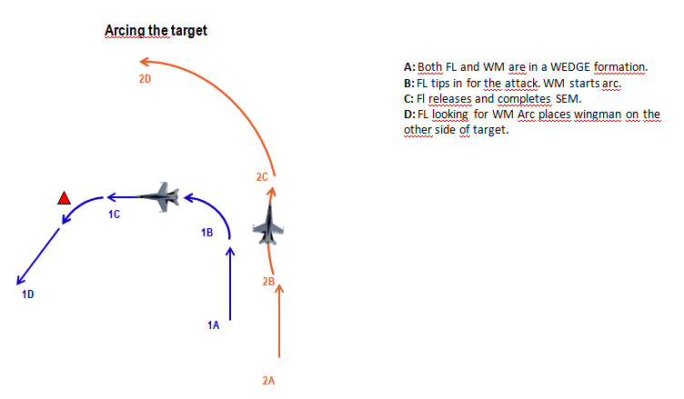

#### Parallel Attack Axis

Similar to Arcing, the different is the “shooter” provides a verbal cue to clear the cover aircraft to maneuver parallel the attack axis. The verbal cue will be briefed prior to the attack either on the ground or in the air. The cover aircraft establishes a position to employ ordnance and monitor the target area and “shooter” during roll-in and pull-off. When the “shooter” pulls-off the cover aircraft will be in a predictable point aiding the “shooter” regaining visual. This will minimize “Blind” calls from the “cover” or “shooter.”

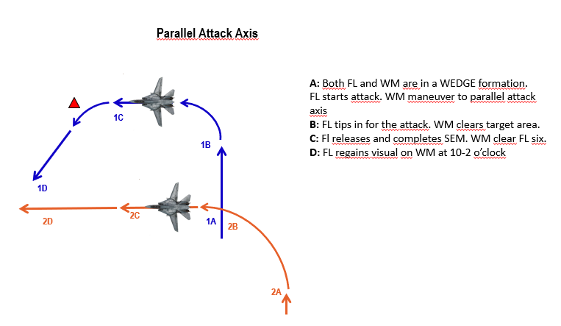

## High/medium altitude tactics

#### Shooter-Cover

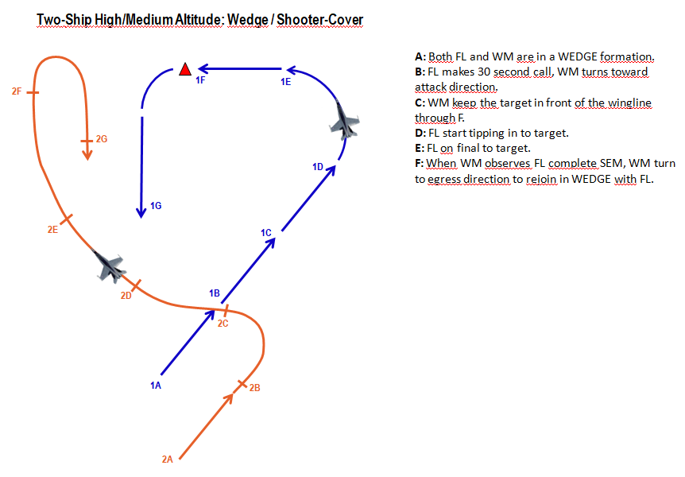

Shooter-Shooter

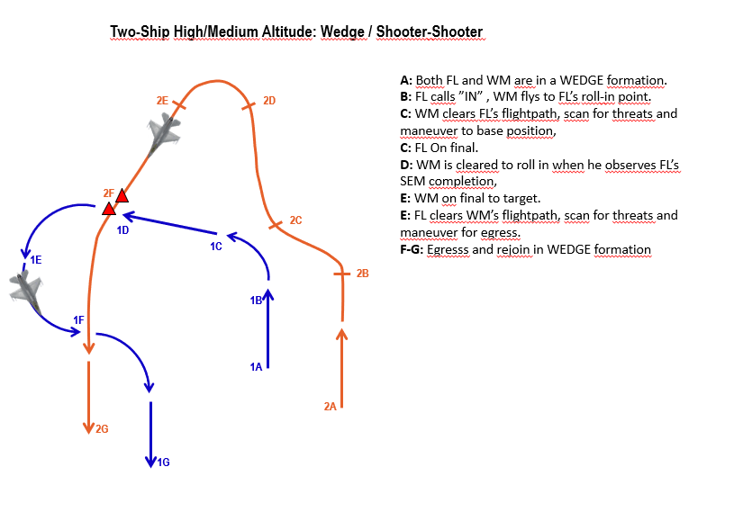

##### Two-ship high/medium altitude: Line abreast , standoff attack/ shooter-shooter

##### 

## Low altitude tactics

#### Shooter-shooter

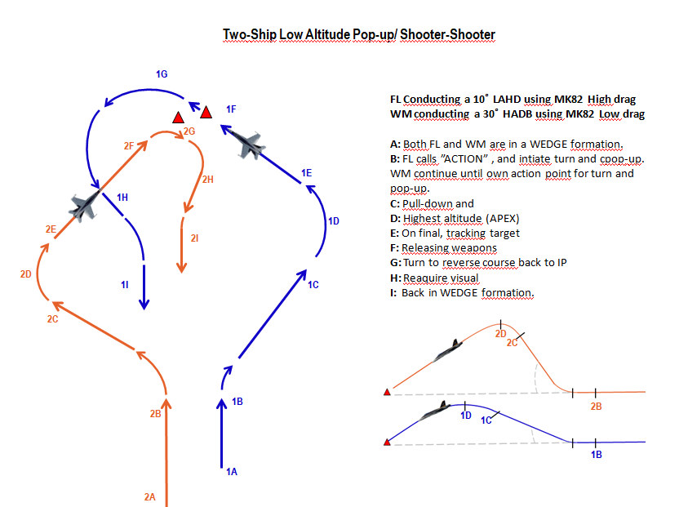

Figure 1: In this attack FL have a actionpoint 5,1 nm away from the target, flying at a speed of 500kts at 400ft AGL. At Action, FL does a 20 degrees right turn, and conducts a 3-4 G pull to 15 degrees with full AB. APEX at 1700ft AGL (target altitude). WM have a actionpoint 5,1 nm away from target, flying at 500kts at 400ft AGL. At Action, WM does a 30 degree right turn and conducts a 4G pull to 45 degrees with full AB. APEX at 5800ft AGL (target altitude).

##### Two-ship low altitude: Line abreast, Maverick attack / Shooter-Shooter

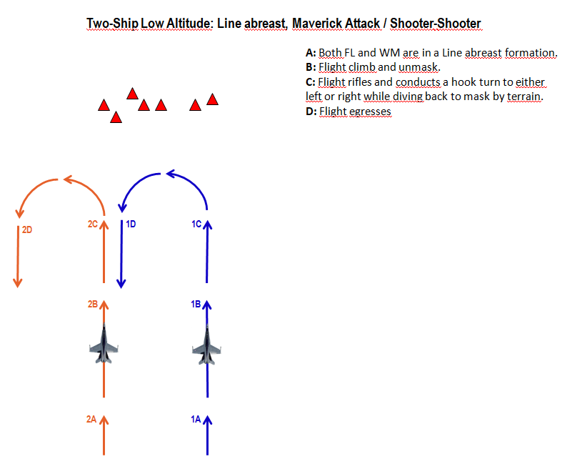

## Buddy lasing

ADD BUDDY LASING

## Ground lasing

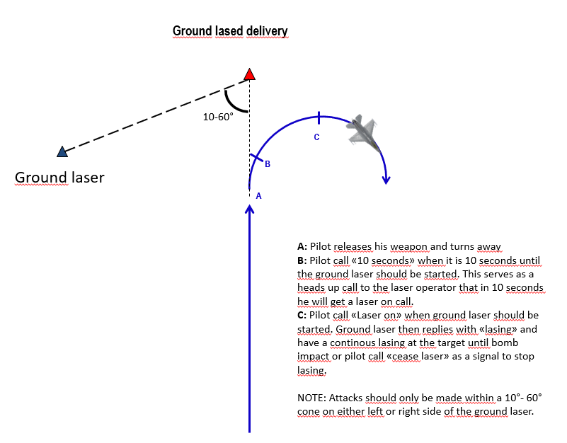

## Holding patterns

At times it may be necessary to hold at a specific point, or area in order to

When possible the flight should hold in a area with enough airspace to hold in an area of relatively low AAA/SAM activity that also provides a good position to observe the target area.

Racetrack: An oval holding pattern with straight legs and with standard 180 degree turns on each end. Racetrack is anchored into a fix which can be TACAN or waypoint or a geographical feature.

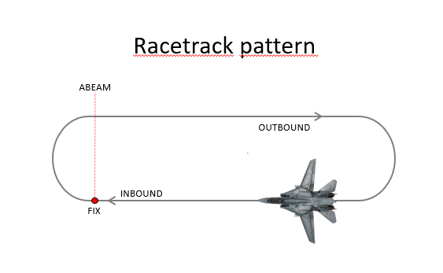

Figure Eight: The same as racetrack pattern except the turns at each end of the pattern are made toward the target area or a fix and are 230 degrees of turn instead of 180 degrees.

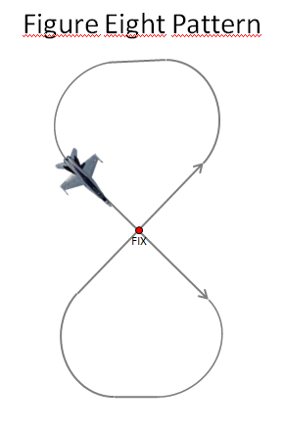

Wheel orbit: Circle around the designated target or a fix. Appropriate for nonlinear battlefields with pockets of enemy activity

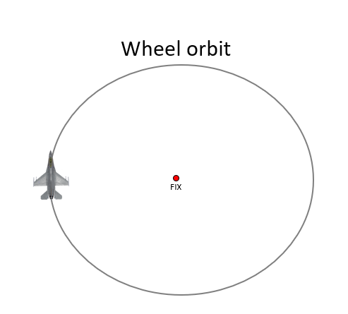

Range pattern

## Mission profiles

#### High Altitude Tactics

High altitude tactics are generally flown over 25,000 feet mean sea level (MSL). Aircrews use high altitude tactics to remain above the threat's low to medium altitude surface to air systems.

##### Advantages

• Reduces aircraft fuel consumption.

• Reduces aircraft navigation difficulties.

• Improves aircraft tactical formation control and employment.

• Reduces aircrew workload.

• Allows considerable airspace for aircraft maneuver for target attack and threat reactions.

• Improves communications between aircraft and control agencies.

• Increases the range of weapon deliveries because of easier recognition and acquisition of large targets (e.g., buildings or large troop and vehicle concentrations) with aircraft sensors.

• Allows flight over the threat's AAA and medium altitude SAM systems.

##### Disadvantages

• Enemy acquisition radar can detect the attack forces at longer ranges. This may allow the enemy to alert air defence assets of incoming Counterland missions.

• May require a strong Counterair warfare support packages to degrade or suppress the enemy's air defence assets.

• Enemy high altitude SAM systems have longer-range employment envelopes to counter friendly aircraft.

• Recognition and acquisition of medium to smaller targets may be very difficult.

• Unguided munitions may not be as accurate making the attack of small point targets difficult.

• Weather or environmental conditions may prevent visual acquisition of targets or target areas.

#### Medium Altitude Tactics

Medium altitude tactics are flown between 8000 to 25,000 feet MSL and have most of the same advantages and disadvantages as high altitude tactics. However, visual acquisition of some targets may be enhanced and weapons accuracy of unguided munitions may improve. In most cases, fixed-wing AR and SCAR missions will be flown at medium altitudes to prevent exposure to AAA threats and low altitude SAMs. However, in situations where the threat is negligible or the potential targets are small, a transition to low altitude may be done as required to acquire or attack smaller targets.

#### Low Altitude Tactics

Low altitude tactics are flown below 8000 feet above ground level (AGL). Aircrews use low altitude tactics to keep the attack force below enemy early warning radar coverage as long as possible. Marginal weather or attacking smaller targets may cause aircrews to use low altitude tactic attacks. Low altitude tactics may be utilized when attacking targets within the FSCL to aid in the identification of friendly surface force and prevent fratricide.

##### Advantages

• May be used to surprise the enemy by reducing the enemy's reaction time due to terrain masking and late radar detection.

• Reduces the chance of attack from enemy SAM systems by using terrain for masking.

• Reduces the enemy's SAM weapons envelope and lethal zones during high-speed low altitude ingress and egress.

• Increases the aircrews' ability to recognize and acquire smaller targets.

• Improves aircraft maneuvering performance.

• Reduces the capability and range of the enemy aircraft radar to detect friendly aircraft.

• Allows aircrews to acquire targets during degraded weather or reduced visibility.

• May be utilized below an overcast or reduced visibility.

##### Disadvantages

• May allow enemy visual or listening posts to detect incoming aircraft.

• Visual acquisition of the target may be delayed as altitude decreases.

• Aircraft fuel consumption may be higher.

• Navigation and terrain avoidance are more demanding and require a higher level of aircrew skill.

• Exposure to small arms, AAA systems, and IR-guided weapons increases.

• Less time available for aircraft to react to enemy surface to air systems.

• Communication and control are more difficult.

During the execution of Counterland operations, mission commanders or flight leads may determine it is more beneficial to use a combination of altitude profiles. For example, the target may be a great distance from aircraft operating bases, however, the target is very small or the cloud cover is low. In this case the Counterland flight may use a high altitude ingress, low altitude target attack, and a high altitude egress. The combination of altitude profiles should be designed to optimize the aircrews' ability to attack targets, maximize the advantages of some profiles, and minimize the disadvantages associated with others.

The altitude profile discussed in the previous paragraph's example is typically referenced to as a high-low-high profile. Profiles may be flown as low-low-high, where the Counterland mission commander desires to maintain stealth on the ingress and target attack but fuel considerations require the egress at a higher altitude. Altitude profiles are determined based on aircraft performance, threat and friendly situation, aircrew training, and experience of Counterland aircrews.

#### Example mission profiles

##### High-High-High

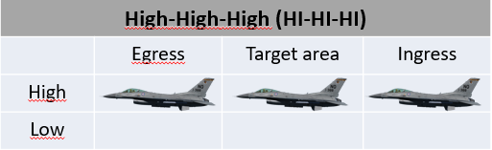

##### High-Low-High

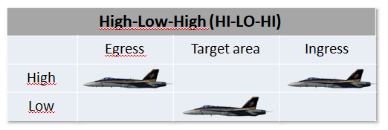

##### High-Low-Low

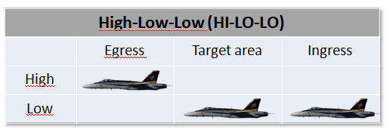

##### Low-Low-High

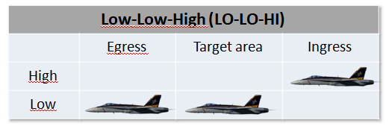

##### Low-Low-Low

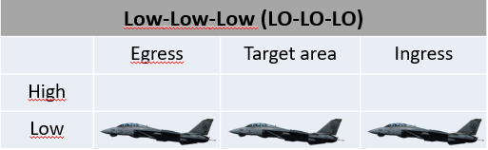

# Chapter 3: Weapon Delivery Methods

### Gun deliveries[1]

**Low Angle Strafe (LAS)**  
Planned dive angle at delivery of 15 degrees or less. Minimum range to target is 2,000 feet. Minimum recovery altitude is 75 feet AGL. Number of rounds per event is 100.   
  
LAS deliveries are most effective against soft/lightly-armoured targets and will normally result in a higher dispersion of bullet impacts than high angle deliveries. The lower dive angle used on LAS deliveries allow for both lower aircraft speeds and operation at lower altitudes without the need for a pop-up profile, this allow the aircraft to carry out multiple passes on a single target in rapid succession and often allow the pilot to maintain visual contact with the target area throughout the attack. LAS deliveries are also ideal for attacking soft target such as supply convoys and troops with or without PAC.  
  
The main disadvantages of LAS deliveries are increased exposure to enemy fire due to the low altitude and short range to the target, as well as relatively high bullet dispersion patterns resulting in reduced effectiveness against armoured targets.

**High Angle Strafe (HAS)**  
Planned dive angle of greater than 15 degrees. Minimum recovery altitudes are 1,000 feet AGL for planned dive angles 30 degrees or less and 1,500 feet AGL for planned dive angles above 30 degrees. Minimum range to target is 2,000 feet. Number of rounds per event is 100.  
  
HAS deliveries are most effective against heavily armoured targets such as main battle tanks and will normally result in a low dispersion of bullet impacts. HAS deliveries are also ideal for point targets where a tight bullet impact pattern is desired and/or where targets are located in mountainous terrain.  
  
The main disadvantages of HAS deliveries are a limited tracking time due to the high aircraft speed in the dive and the need for an early escape manoeuvre to recover from the dive. It can also be difficult to maintain visual contact with the target due to the requirement for a high starting altitude. The need for a high starting altitude also places the aircraft at risk of early detection and/or high risk of engagement by SAM/AAA systems during the attack.

**Unguided Free Fall Munition Deliveries[2]**

**LOW LEVEL DELIVERIES  
  
Visual Level Delivery (VLD)**  
The VLD is a level delivery with a release angle of less than five degrees of climb or dive; it is often performed at very low level (sub 1000 ft. AGL) utilising high drag munitions such as the MK-82AIR.   
The minimum recovery altitude is the safe escape/fuse arm range for the ordnance being delivered, or 200 feet AGL, whichever is higher.   
  
In training pilots will not descend below the specific range altitude if higher than stated above. Training hit criteria for a VLD are as follows: 125 feet (38 meters) for a computed delivery and 250 feet (76 meters) for a manual delivery.  
  
The VLD is of somewhat limited use in the A-10C as the aircraft’s comparatively low airspeed means it remains in proximity to the target and any defences for a longer period of time than other higher performance aircraft, however for targets where the primary threat is medium/high altitude SAM systems it is still useful. Unlike pop-up deliveries (see below) the VLD is flown at a near constant altitude from ingress to the end of the SEM (and normally egress). The VLD will normally be used in situations where a NOE ingress and egress is required and only one attack on the target (per aircraft) is planned. When multiple aircraft will be attacking the same target, time and heading separation is vital it order to prevent following aircraft passing through any fragmentation and deny the enemy the ability to predict the arrival of attackers.

**Low Angle High Drag (LAHD)**   
An LAHD attack, as the name would suggest is performed using high drag munitions such as the MK-82AIR, it is also used to deliver CBUs from low level. The delivery itself is carried out with a dive angle of less than 30 degrees and the minimum recovery altitude is safe escape/fuse arm for ordnance being delivered, one-half the computed altitude loss during dive recovery or 100 feet AGL, whichever is higher.   
  
Training hit criteria are 75 feet (23 meters) for a computed delivery and 105 feet (32 meters) for a manual delivery.  
  
The LAHD delivery is usually performed with a low level ingress, similar to the VLD above, but rather than remaining at a constant altitude a “pop-up” is performed on the final ingress. This allows the attacking aircraft to remain at low level and utilize terrain masking (where possible) to remain out of range of any defenses at the target until the last possible moment. The aggressive nature of a pop-up followed by a dive attack further reduces the attacking aircraft’s exposure to ground fire, especially when combined with a low level egress.

‘

**Low Angle Low Drag (LALD)**  
An LALD attack is similar to the LAHD outlined above; it is also performed with a dive angle of less than 30 degrees and can be performed following a “pop-up”, although it can also be initiated from a level ingress at a higher altitude. The main difference is the weapon type used, whereas the LAHD is carried out with high drag munitions, the LALD (as the name would suggest) is performed with low drag munitions such as the standard MK-82 or MK-82AIRs in low drag configuration. The minimum recovery altitude is the safe escape/fuse arm height for the ordnance being employed, or 800 ft. AGL, whichever is higher.  
  
Training hit criteria is 100 feet (31 meters) for a computed delivery and 175 feet (53 meters) for a manual delivery.  
  
The LALD delivery can be performed with a low level ingress and a “pop-up” on the final ingress or from a higher altitude without a pop-up. The main noticeable difference between an LALD and LAHD delivery is the altitude, at which the weapons are released, or the attack aborted, and the SEM must be carried out due to the reduced flight time and shallower flight path of the low drag munitions employed. This means that when performed with a pop-up from low level the climb is longer in duration and/or steeper. This may make a pop-up LALD impossible in the A-10C depending on aircraft weight/pressure altitude etc. and consideration should be given to these factors when planning such deliveries.

**Dive Bomb (DB)**  
The Dive Bomb delivery is probably the most familiar to the majority of pilots; it is performed with a dive angle of between 30 and 60 degrees and from a higher initial altitude than either LAHD or LALD. Although it could be carried out following a “pop-up”, due to the higher dive angle and therefore minimum recovery altitude it would be difficult to accomplish in a low speed low power aircraft such as the A-10C as the climb would need to be much steeper/longer. The minimum recovery altitude is the safe escape or fuse arm height for the ordnance being simulated, or as required to recover above 1,000 ft. AGL, whichever is higher.   
  
Training hit criteria is 85 ft. (26 meters) for a computed delivery and 145 ft. (44 meters) for a manual delivery.  
  
The DB delivery is one of the most common delivery types for the A-10C and is a very accurate method of delivering weapons using CCIP. It should be noted however that due to the higher ingress altitude terrain masking is normally impossible and extreme care should be taken in high threat environments, as the delivery will bring the attacking aircraft well inside the MANPADS and AAA WEZ. Mutual support is vital to ensuring the safety of the attacking aircraft, and wingmen should be positioned in a way that allows a clear view of the target and the attacking aircraft’s ingress, attack and egress.

**Unguided Free Fall Munition Deliveries**

**MEDIUM LEVEL DELIVERIES  
  
High Altitude Dive Bomb (HADB)**   
The HADB is almost identical to the Dive Bomb outlined in the previous chapter; the only real difference between the two delivery methods is the altitudes at which they are performed. Like the DB the HADB is performed with a planned dive angle of between 30 degrees and 60 degrees, but with a minimum recovery altitude of at least 4,500 ft. AGL.   
  
Training hit criteria is 125 ft. (38 meters) for a computed delivery and 250 ft. (76 meters) for a manual delivery.  
  
The HADB, like the DB, is a very accurate method of delivering dumb munitions on target but due to the higher altitude at which it is performed it reduces the risk to the delivery aircraft from SHORAD systems such as AAA or MANPADS. It should be noted that 4,500 ft. AGL is the minimum recovery altitude for the HADB delivery and pilots/flight leads can set a higher minimum recovery altitude if desired/appropriate. When performing a HADB delivery it is vital that the pilot pays attention to the altitude and airspeed in the dive, as well as the amount of time spent tracking the target. It is all too easy to become fixated on the target, ignore the HUD RTSE cues and then find yourself below the minimum recovery altitude in the range of the SHORAD systems you were hoping to avoid, or even colliding with the terrain. The tracking phase of HADB deliveries should be less than 6 seconds; excessive time spent in the dive trying to force the pipper on the target from a poorly executed dive/turn is without doubt the biggest mistake pilots make.

**High Altitude Release Bomb (HARB)**   
HARB is a diving delivery with a planned dive angle of 30 degrees or greater, just like DB and HADB, where it differs is the minimum recovery altitude (and therefore the release altitude). The minimum recovery altitude for a HARB delivery is 10,000 ft. AGL, twice the height of the HADB.   
  
Training hit criteria is 255 ft. (78 meters) for a computed delivery and 510 ft. (136 meters) for a manual delivery.   
  
The HARB is not a delivery method which will be employed by the A-10C very often as it is primarily used by fighter aircraft attacking large, heavily defended targets. Due to the high release altitude, and therefore large slant range, accuracy is limited (despite still being a CCIP delivery) which means the HARB is of limited value when attacking small, mobile targets such as vehicles and troops. It is worth noting however, that HARB may be useful in cases where it is important to get weapons on target but the threat situation makes a low level attack inappropriate. When planning such a delivery the reduced accuracy should be considered and thought given to using multiple aircraft against a single DMPI to ensure sufficient weapons impact the target in order to achieve the desired effect.

**Unguided Free Fall Munition Deliveries**

**TOSS DELIVERY**   
Weapon delivery in which an aircraft system is used for target designation followed by a climbing Continuously Computed Release Point (CCRP) weapon release. It should be noted that toss deliveries are generally less accurate.

**Low Altitude Toss (LAT)**   
LAT deliveries involve a release altitude below 10,000 ft. AGL all the way down to 0 ft. AGL. The minimum recovery is the safe escape altitude/distance for the ordnance being delivered.   
  
  
  
The LAT delivery is the most accurate CCRP delivery as the low release altitude limits the effect of wind and aiming error on the weapons during their flight. While easier to perform than a diving CCIP delivery, the LAT delivery is also less accurate and may require releasing more weapons and/or more attacks to deliver the same damage to the target as a single diving delivery. Due to the release aircraft’s attitude and airspeed at the point of weapon release, the weapon time of flight will be greater than a diving delivery with the same release altitude.

As it already says, this is a low altitude profile. The idea for this delivery is to fly in low and below the radar and also give you some distance from the target at the same time. You will toss the bombs from a distance and turn away before you over fly the target. This will give you the advantaged of surprise and you stay as far as possible from the target. The disadvantage of this delivery is that the accuracy is lower then the other modes. So you have to select this profile only when everything fits to the occasion. Using guided weapons is a good option, and also cluster bombs will fit very nice. Dumb bombs are not so good for this profile because you will probably miss the target unless the target is very large like a hanger.

**Medium Altitude Toss (MAT)**   
A MAT delivery is identical to the LAT described above but with a release altitude of 10,000 ft. AGL or above. The minimum recovery is the safe escape altitude/distance for the ordnance being delivered.  
  
Training hit criteria is 300 ft. (91 meters).  
  
The MAT delivery has the same list of pro’s and con’s as the LAT, the notable difference being the higher altitude magnifies the effects of wind and aiming error on weapon accuracy. While the higher altitude may negate the threat posed by AAA and/or MANPADS it should be considered that it makes the delivery aircraft and even better target for hostile aircraft and MERAD/LORAD systems.

### Medium/high altitude tactics.

Are flown above 8,000ft above ground level(AGL). High altitude bombing can be described as bombing with the height of release over 15,000 ft AGL.

###### Attack. Types of delivery

Level: Used for guided and unguided free-fall weapons. Release point may have bomb ranges outside of visual range.

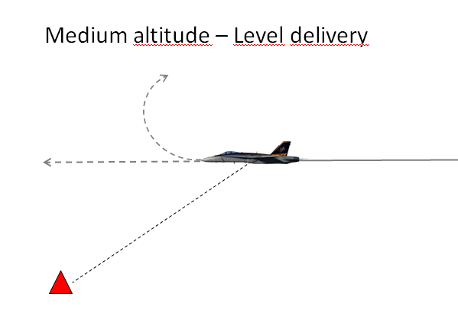

Dive: Used for guided, unguided and forward firing ordnance, these dive deliveries typically use dive angles of 15 to 60 degrees.

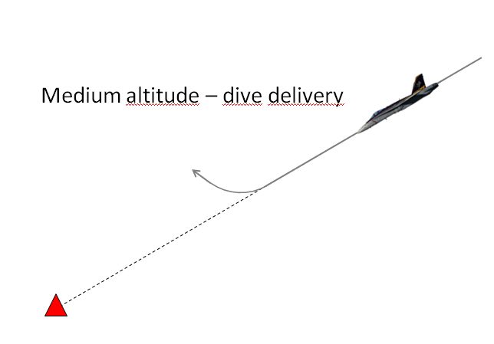

### Low/very low altitude tactics

Are flown below 8,000ft AGL. Low altitude bombing can be described as bombing with height of release between 500 and 8,000ft AGL. These tactics are employed when threat system capabilities and/or weather conditions preclude aircraft operating at higher altitudes.

###### Attack. Types of delivery

Level: Deliver ordnance with a wings level pass over the target

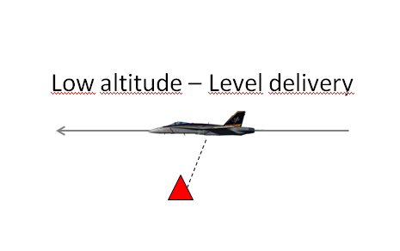

Loft: To execute a loft delivery the flight proceeds inbound to the target from the IP. At a calculated point the aircrew starts a loft maneuver pull up. Once released the weapon continues an upward trajectory while the aircrew executes follow-on tactics or egresses from the target area.

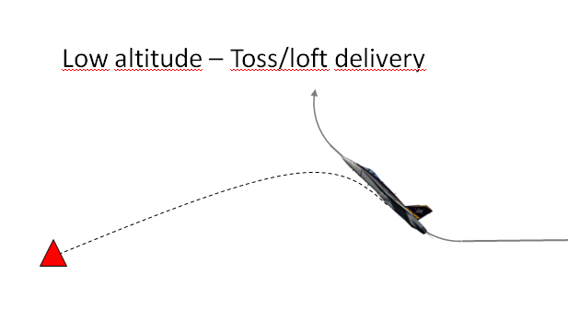

Pop-up: To execute a pop-up delivery the CAS flight proceeds to the target from the IP at low/very low altitude. As the CAS flight nears the target, they pop-up to the desired altitude and execute a level or dive delivery.

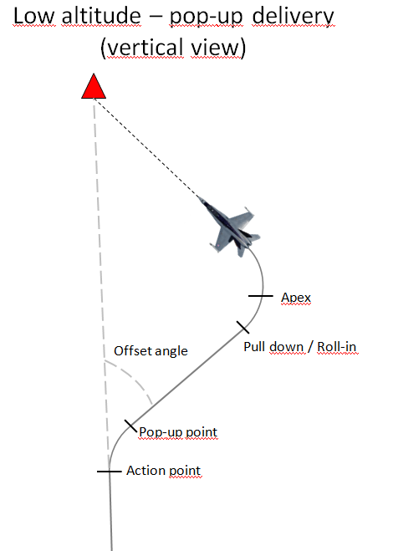 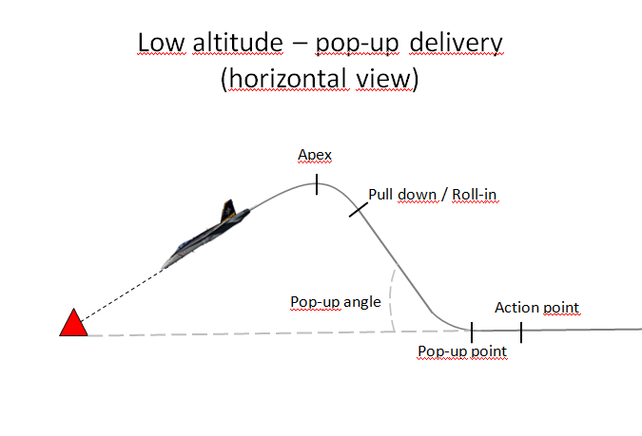

Dive deliveries: Used for both free fall and forward firing ordnance. These deliveries use dive angles of 5 to 45 degrees.

## Pop-up deliveries

#### Low Angle Low Drag Bombing (LALD) (10º–20º)

The delivery is designed for low-angle delivery of low-drag weapons. Exercise care in computing

release altitudes to assure fuze arming and safe escape. Planned angle-off for this type of delivery can

vary from 15º–90º, although optimum angle is approximately 2 x climb angle. Accomplish pull-up to the

planned climb angle (15º + 5º and 20º + 10º) and pull-down at the preplanned pull-down altitude. Take

care to properly monitor the altimeter to determine the proper pull-down point since the apex altitude for a

LALD delivery is considerably higher than for a LAHD delivery and visual cues can be deceiving. For

CCIP deliveries roll out with the target approximately halfway between the FPM and CCIP pipper. Pay special attention to the altimeter to assure you deliver at or above the planned altitude.

#### Low Angle High Drag Bombing (LAHD) (10º–15º)

This attack maneuver is very similar to that of low-angle strafe. It is designed for low-angle delivery

of high drag weapons. The approach to the target is normally planned to be made from a run-in heading

offset 15º–30º from the attack heading at a minimum of 450 KCAS. At the desired pop point, a 3–4 G

pull-up is initiated to the planned climb angle (usually dive angle plus 5º). At the preplanned pull-down

altitude, the aircraft should be rolled towards the target and the nose pulled down to roll out just as you

would in any low angle bomb delivery. Normally, this type of delivery is planned to allow 3–5 seconds of

tracking/designate time prior to arriving at planned release altitude. For CCIP deliveries, roll out with the

target approximately one-third down between the FPM and CCIP pipper.

.

#### Low Angle Strafe (LAS)

Although the planned angle-off from the target can vary, normally the approach to the target is

planned to be 15º–30º from the desired attack heading at a minimum of 450 KCAS. At the planned pop

point, select military power and begin a 3–4 G pull-up to the desired climb angle. This is normally

planned to be equal to the planned delivery dive angle plus 5º. At the preplanned pull-down altitude, roll

the aircraft and begin a pull-down to achieve the desired dive angle. Monitoring the HUD pitch lines in

relation to the target will simplify achieving the planned dive angle. Make an unloaded roll out with the

CCIP pipper approximately 100' short of the target. After roll out, track and fire just as in a

curvilinear/box strafing pass.

#### High Altitude Dive Bombing (HADB) (30º–45º)

This delivery is designed for high angle delivery of low-drag weapons in a high threat environment.

During mission planning, aircraft configuration must be taken into account to ensure this type of approach

is feasible, i.e., two wing tanks with six MK 82s may not be an option for high 45º delivery. The

approach to the target is normally at 500 KCAS (minimum) to an action point 4–5 NM short of the target.

At this point, a check turn between 20º–30º is required to obtain the necessary offset. At the desired pop

point, a 4 G pull-up is initiated to the planning climb angle (usually dive angle plus 15º) in full AB. Once

the pop-up is established, time should be devoted to target acquisition which can be difficult since you will

be looking down over the canopy rail. Monitor the altimeter as the pull down altitude approaches due to

the rapid climb rate to ensure correct parameters. At the apex, the aircraft will be at or nearly inverted, so

care must be taken to roll out with the proper AOD. Attacks should be planned to provide 5 seconds of

tracking/designate time prior to arriving at the release altitude. For CCIP deliveries, roll out with the

target approximately two thirds of the way down between the FPM and CCIP pipper.

After releasing weapons, the threat will dictate the type of recovery, but for peacetime training recover with a 4–5 G pull until the nose is above the horizon then execute the egress plan.

#### Visual Level Delivery (VLD) (0º–5º)

This type of delivery is flown using CCIP when the weather or threat precludes steeper dive angles.

Ingress the target area at low altitude, terrain masking and constantly jinking until just prior to weapon

release. Since your approach to the target is a random flight path, good planning is required to arrive at

an action point where target acquisition is initiated and weapons delivery commenced. If a level delivery

is planned, simply arrive at the target on your proper altitude with the CCIP pipper properly positioned. If

a 5º diving delivery is planned, initiate a 10º pull-up followed by a pull-down/bunt approximately 500'

below planned apex. Pay particularly close attention to precise release parameters, fragmentation clearance and ground avoidance. The recovery portion of this delivery must be emphasized to ensure safe escape criteria from your munition.

### Safe Escape Maneuvers (SEM)

**Level Straight Through (LST)**

This is the simplest of the SEMs and is exactly what its name suggests; safe escape is provided by a level, constant speed, no-turn profile. Maintain this SEM until 3 seconds after the TOF of the last bomb in the stick. This is only used with a level release, like the VLD you might use with MK-82AIRs.

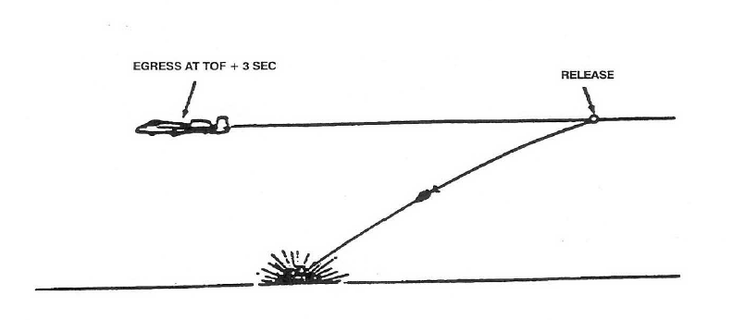

**Turning (TRN)**

While the TRN SEM isn't often planned in the A-10, the tactical situation may dictate its use. It's valid for attacks using up to 20° of dive. After release, simultaneously apply MIL and establish a 4g loaded roll (60-85° of bank) in the desired direction. As the TVV nears 5° of dive increase your bank angle to maintain 4g and 5° of dive for at least 60° of heading change.

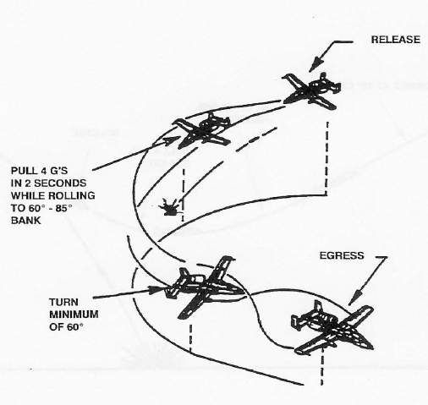

**Turning Level Turn (TLT)**

This is far more common than TRN, and is also used for deliveries with up to 20°. After release, simultaneously apply MIL power (MAX in the A-10) and establish a wings-level 4g pull within 2 seconds. As the TVV nears the horizon, perform a 2-4g loaded

roll in the desired direction and establish a 4g level turn for at least 60° of heading change.

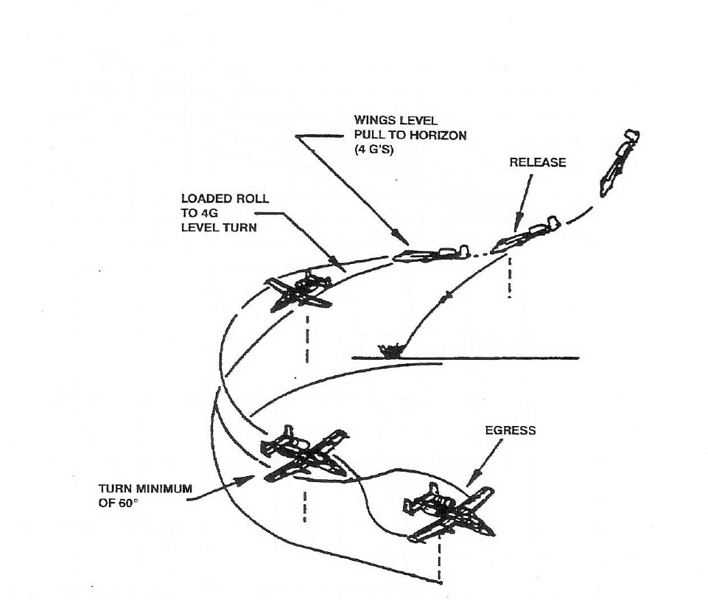

**Climb (CLM)**

The CLM SEM can be used for attack profiles with as much as 60° of dive. After weapon release, establish a 4g pull within 2 seconds. As the nose approaches the horizon, apply MIL power and maintain the 4g pull until the TVV is 20°above the horizon, and then relax the pull until the TVV indicates at least a 30° climb.

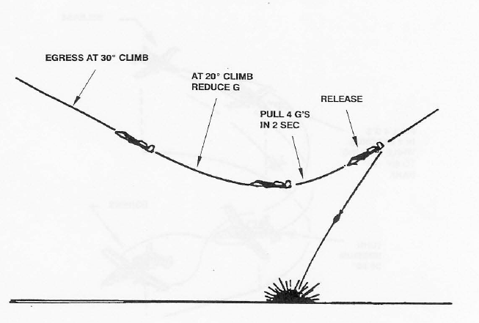

# Chapter 4: Z-Diagrams

##### Z-Diagram explanation Pop-up attacks

This is the maximum altitude during the attack

What kind of profile is shown

This is distance is the action point, where the turn to either side is initated

This is how many degrees to either side is the offset before doing the pull-up

How many degrees is the pop-up.

This is the Planned Release Altitude. Also gives the Minimum release Altitude

This is the dive angle during final

At what altitude should the pilot start his roll-in / pull-down toward target

This is the minimum altitude during the profile

##### Z-Diagram attack profiles High altitude and Medium altitude dive bombs

### 

What kind of profile is shown

### 

What altitude to be at when flying the base-leg

This is the dive angle during final

### 

Speed at weapon release

What speed to be at while flying at the base-leg

Distance at when to tip-in while flying base-leg (Slant range)

This is the minimum altitude during the profile

This is the Planned Release Altitude. Also gives the Minimum release Altitude

## Z-Diagrams 494th

##### Z-Diagram attack profiles Pop-up attacks

#### Low Angle Strafe

#### High Angle Strafe

#### 10˚ Low Altitude High Drag (LAHD)

#### 30˚ Low AltitudeLow Drag (LALD)

#### 40˚ High Altitude Dive Bomb (HADB)

## Z-Diagrams 388th

##### Z-Diagram attack profiles Pop-up attacks

##### Z-Diagram attack profiles High altitude and Medium altitude dive bombs

## Z-Diagrams 108th

##### Z-Diagram attack profiles Pop-up attacks

##### Z-Diagram attack profiles High altitude and Medium altitude dive bombs

1. http://www.476vfightergroup.com/showthread.php?3131-Air-to-Surface-Weapon-Delivery-Methods
2. http://www.476vfightergroup.com/showthread.php?3131-Air-to-Surface-Weapon-Delivery-Methods